Steps to Install Git with All Commands
Steps-1: -
Download the git .exe file from below link
https://git-scm.com/install/windows?utm_source=chatgpt.com
Once .exe file downloaded completed double click on the .exe file and select “next” button till installation completed.
Step-2:-
Once installation completed open the git terminal and use the below command to check the git version whether git installation successfully done or not.
git –version
you will get he below screen like this
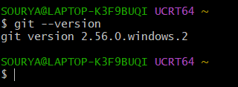
Step-3:-
Configure your name and email for commit history, replacing the examples with your own details:
git config --global user.name "Your Name"
git config --global user.email "you@example.com"
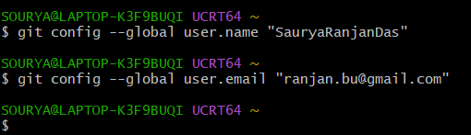

Step-4:- Create a Git repository
Run these commands in your current Git Bash terminal:
git init
You will see the below screen
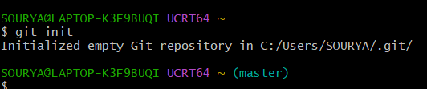
Check the status using below command:
git status
you will see the below screen
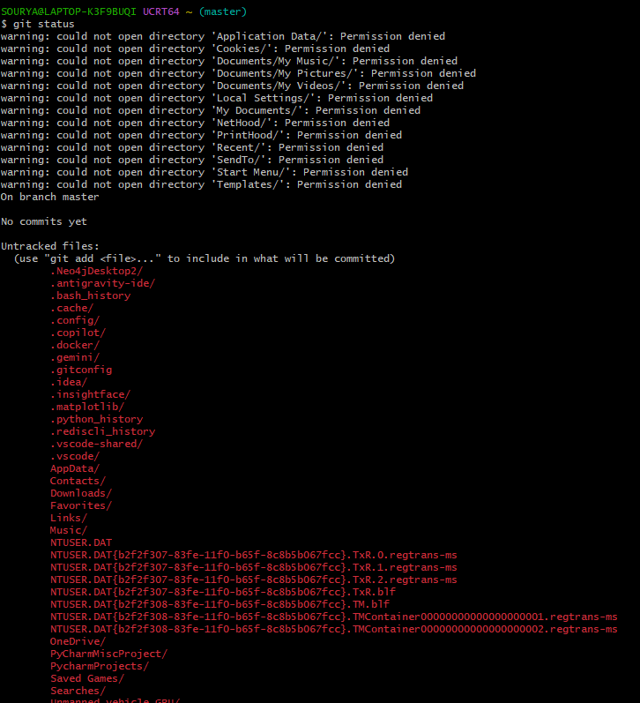

For practice, I recommend creating a separate folder instead as per below command
mkdir GitPractice
cd GitPractice
git init
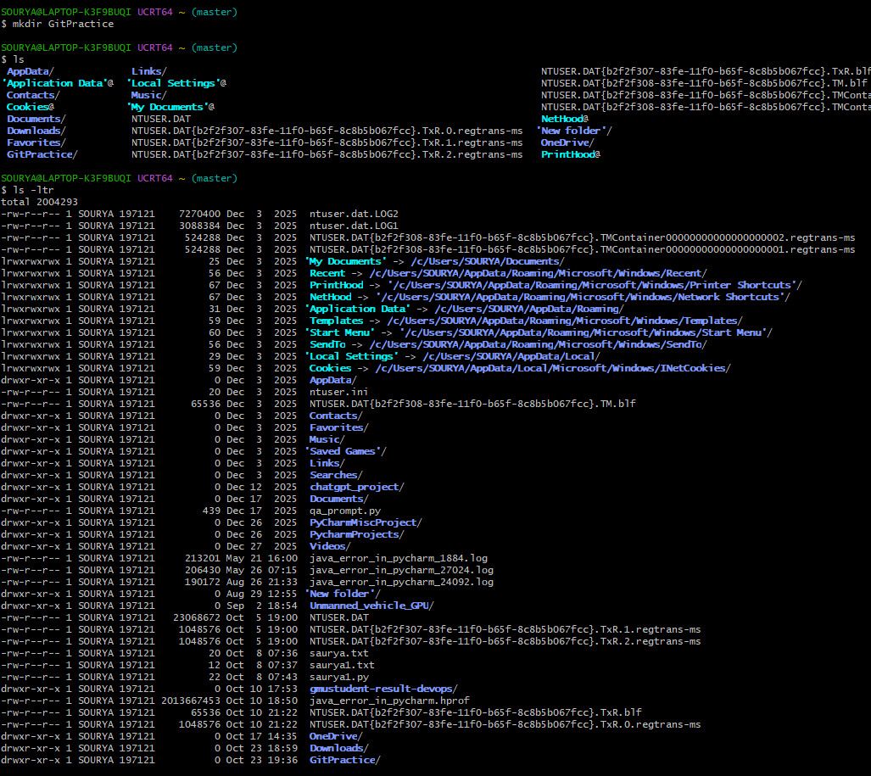

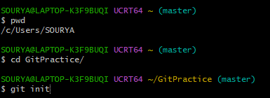
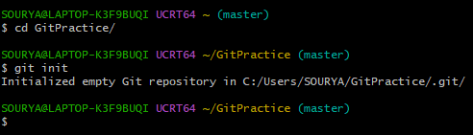
Step-5:- Create the master branch now using below command
git branch -M master
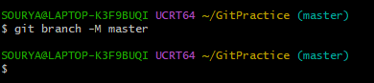
Create a sample file and make the first commit using below git command
echo "Hello Git" > hello.txt
git add hello.txt
git commit -m "Initial commit"
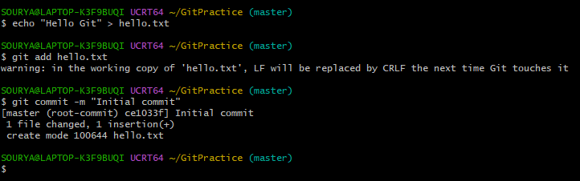
Step-6:- Create the local branch now using below command
git branch local
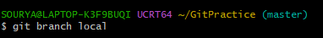
To switch to local branch use the below command
git switch local
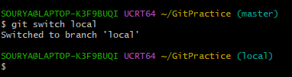

Step-7:- Verify both branches using below command
pwd
git status
git branch
git log --oneline
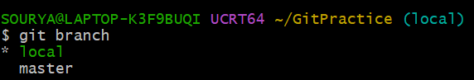

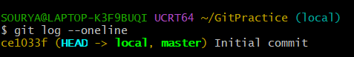

Step-8:- Copy all Python file from local branch to Git Bash using below command

cp -rf "</Local path/"*> "</Destination Path/>"
Example: - I am copying all python file which is in my local branch to destination branch.
cp -rf "/c/Users/SOURYA/OneDrive/Desktop/GMU/TC/Saurya ppt/Week-2/Git_Bash_Python_Guide/"* "/c/Users/SOURYA/GitPractice/"

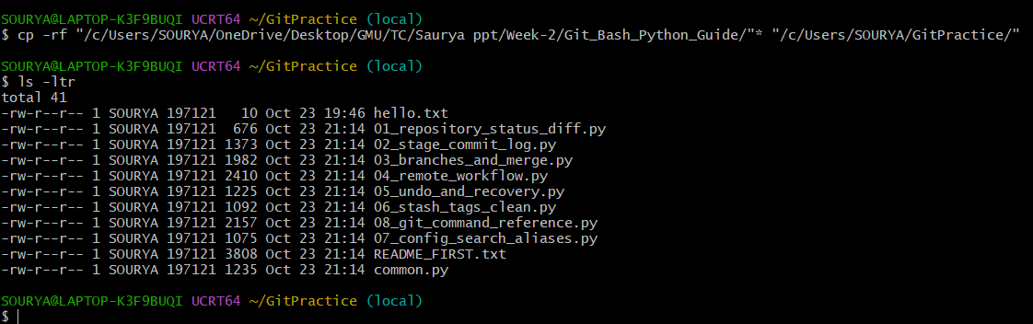
Step-9:- Run a Python file from Git Bash using below command
python --version
python 01_repository_status_diff.py
you will get the below screen if the command run is successful
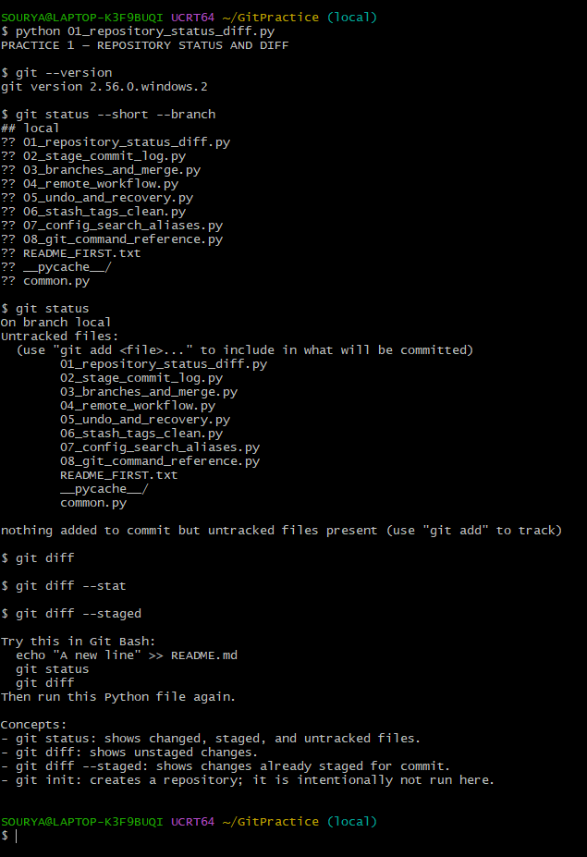
If the python command is unavailable, try:
py --version
py 01_repository_status_diff.py

Step-10:- Practical example: create a branch and merge it using below command
python 03_branches_and_merge.py
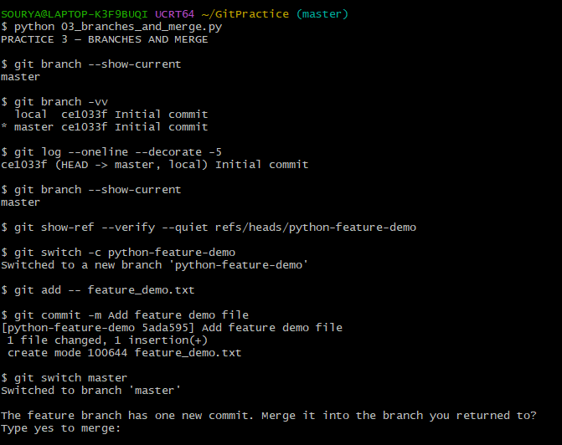
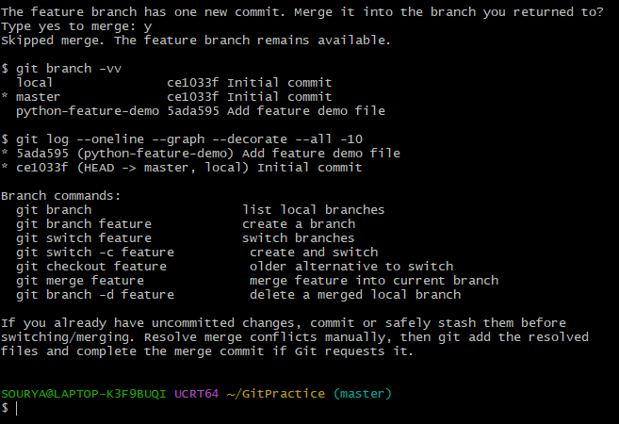
It creates the demonstration branch, creates and commits a feature file, switches back to the original branch, and asks whether you want to merge. Follow the prompts in Git Bash.
Verify the result using below command
git branch
git log --oneline --graph --decorate --all
git status
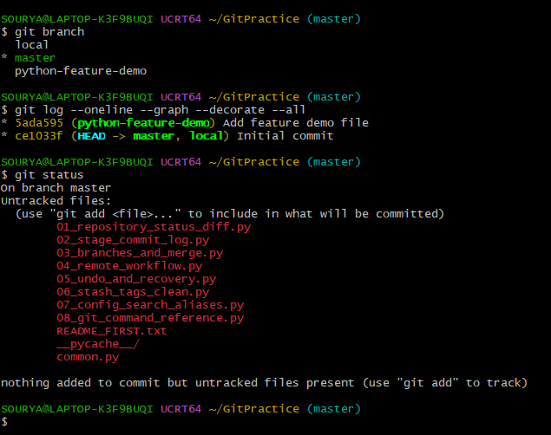

Step-11:- Create the GitHub repository
- Open GitHub.
- Sign in to your GitHub account.
- Click New repository.
- Enter repository name: python-git-demo.
- Select Public (for this exercise).
- Select Add a README file.
- Click Create repository.
Use git clone to download the project
Purpose: Copy an existing remote GitHub repository to your local computer.
Open Git Bash and enter:
cd ~/Desktop
git clone https://github.com/YOUR_USERNAME/python-git-demo.git
cd python-git-demo
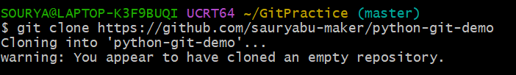

Create a Python file -
Inside the python-git-demo folder, create a file called calculator.py as below

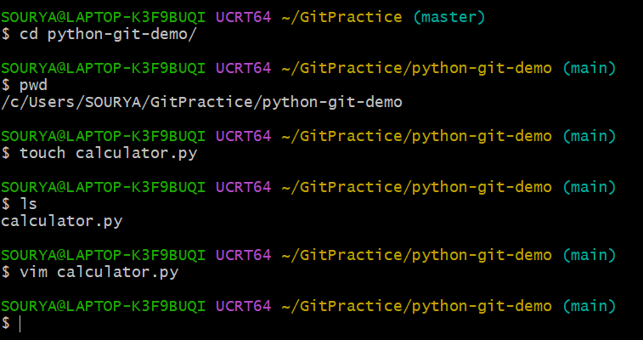

def add(a, b):
return a + b

def subtract(a, b):
return a - b

print("Python Calculator")
print("Addition:", add(10, 5))
print("Subtraction:", subtract(10, 5))

Run the python file using below command
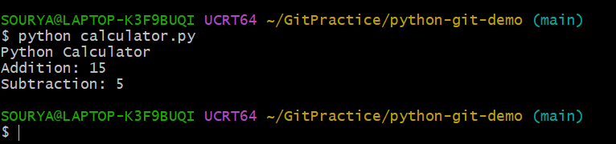
Use git add . to stage the Python file
Purpose: Prepare changed files for the next Git commit.
First, check the status using below command :
git status
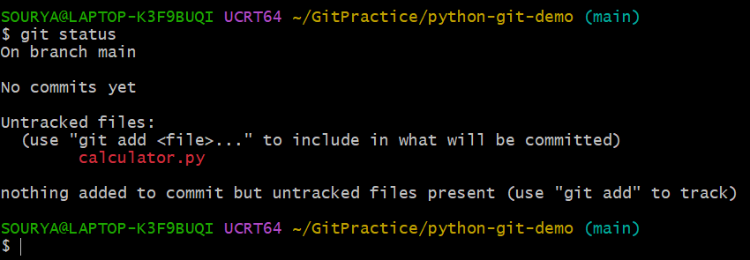

Now run the below command
git add .
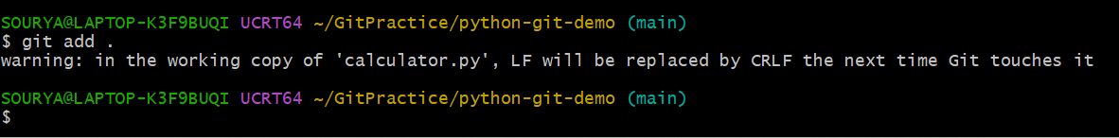
Now again run the below command
git status
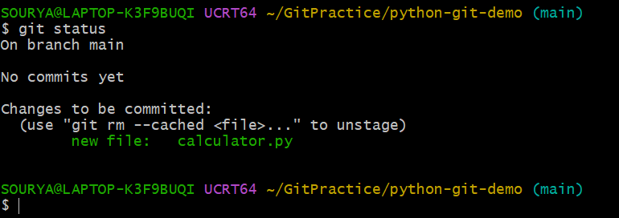
Use git commit to save changes
Purpose: Record staged changes in your local Git repository.
Run:
git commit -m "Added Python calculator program"
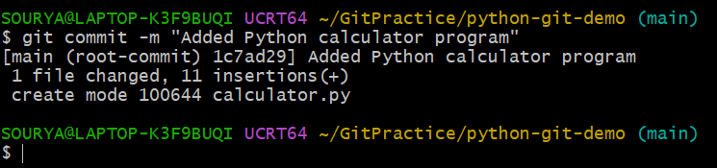
Use git push to upload the project
Purpose: Upload local commits to your remote GitHub repository.
Run:
git push origin main
If you will get 403 error in the git terminal run the below command
git config --show-origin --get-all credential.helper
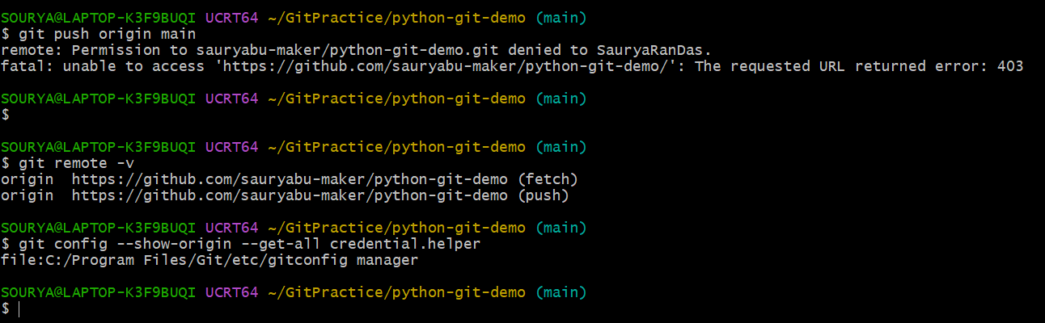
Remove the cached GitHub authentication
If Step 1 shows manager or manager-core, run:
printf "protocol=https\nhost=github.com\n\n" | git credential rejects
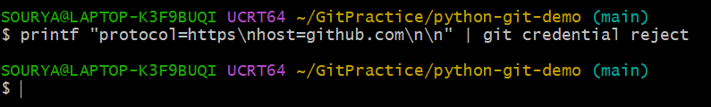
Check your repository URL
Run:
git remote -v
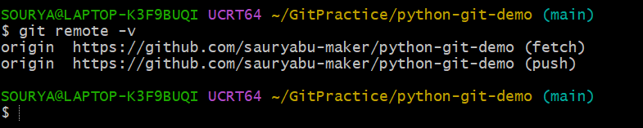
Push again using the correct account
Run:
git push origin main
If you still getting 403 error in git terminal as beloiw
Configure Git Credential Manager for account selection
Open Git Bash in your existing project folder and execute:
git config --global credential.https://github.com.useHttpPath true
Next, run:
git config --global credential.gitHubAccountFiltering true
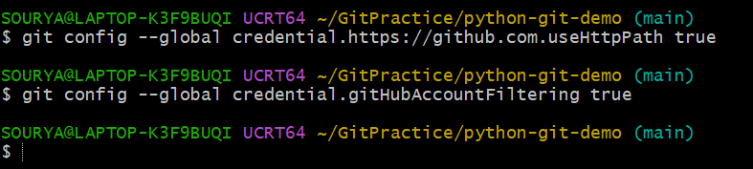
You can also explicitly tell Git Credential Manager which account to use for this repository:
git config --local credential.username sauryabu-maker
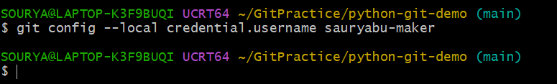
Clear the previous GitHub credentials
Run:
printf "protocol=https\nhost=github.com\nusername=SauryaRanDas\n\n" | git credential reject
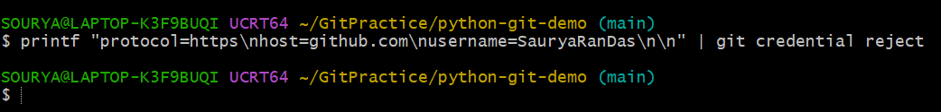
Then clear any cached credentials for the repository owner if necessary:
printf "protocol=https\nhost=github.com\nusername=sauryabu-maker\n\n" | git credential reject
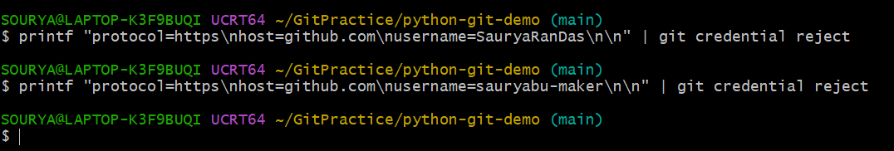
Authenticate again
Run:
git push -u origin main

What is included?
File | Practical topic
01_basic_workflow.py | git init, status, add, commit, diff, log
02_branches_and_merge.py | git branch, switch, merge, commit graph
03_gitignore_demo.py | Create .gitignore, ignore .env, Python cache files and virtual environments
04_remote_workflow.py | git remote, branch -M, and optional git push to GitHub
05_clone_pull_push.py | clone, fetch, pull, push, and collaboration workflow
06_command_reference.py | Command reference for the Git commands covered in your slides
README_FIRST.txt | Installation, setup, execution steps and troubleshooting
3. How to run the Python files in PyCharm
- Extract the ZIP file. For example, extract it into Documents\GitPractice.
- Open PyCharm and select Open, then choose the extracted folder.
- Ensure Git is installed and working. Open the PyCharm terminal and run:
bash git --version
- Run the first Python file:
bash python 01_basic_workflow.py
Or right-click 01_basic_workflow.py in PyCharm and select Run.
- Repeat for the other scripts. The first three scripts create local demonstration repositories inside a practice_repos folder. They do not upload code to GitHub.

